# SunPrints Website Database

# Offline setup for laptops

### Please read carefully

Note: The latest version of this document is always available at s:\sunprints\how to install on laptop.docx. If you got this document from somewhere else, you need to get the latest version instead.

## Part A: Install

These steps only need to be done once per computer.

1. Download the node.js software <https://nodejs.org/dist/v16.17.0/node-v16.17.0-win-x64.zip>

2. Extract the contents of the zip file to a folder on c: drive. You should end up with a folder on c: drive named c:\node-v16.17.0-win-x64. Before continuing, verify this.

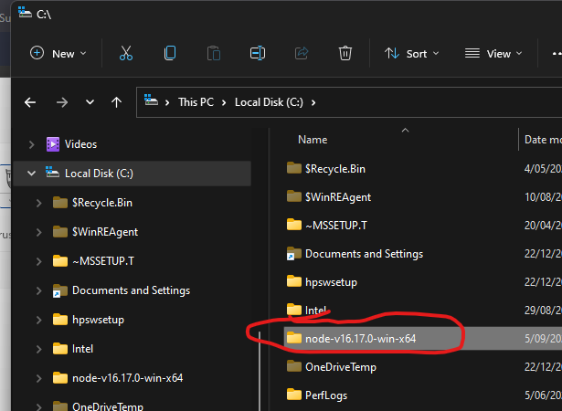

3. Create another new folder named "c:\sunprintsweb"

4. Copy all the files from s:\website to c:\sunprintsweb.

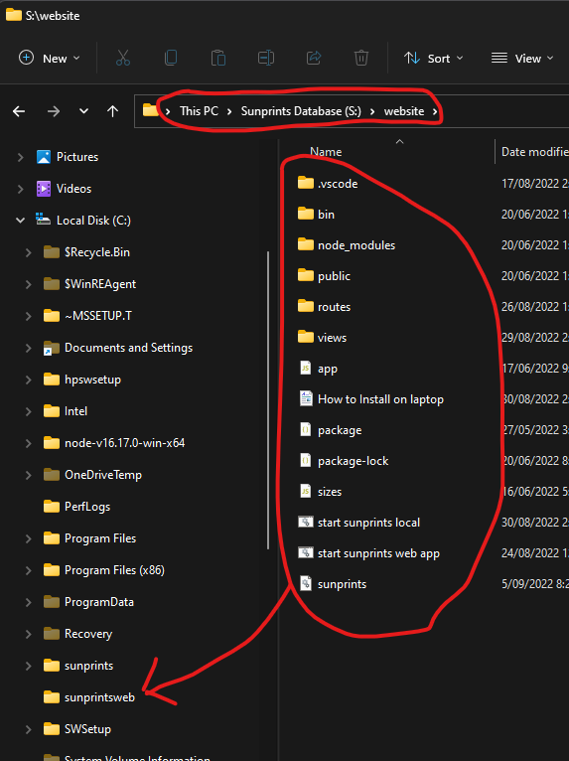

## Part B: Running locally

Start the server by double clicking the "start sunprints local" command

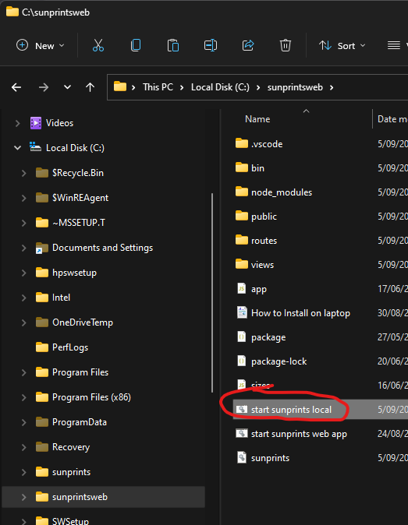

This will open another command prompt window.

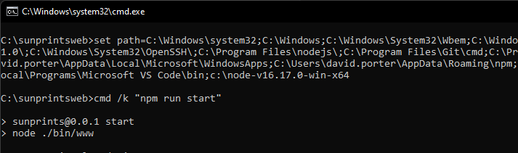

**Leave this window open.** As long as it is open, you will be able to access the local running wesite.

Now you can point your browser to the server which is running on localhost (that is, your local pc)

<http://localhost:3000>

When you are running on your local pc, you will see a message: Running on local server — Not Live Data

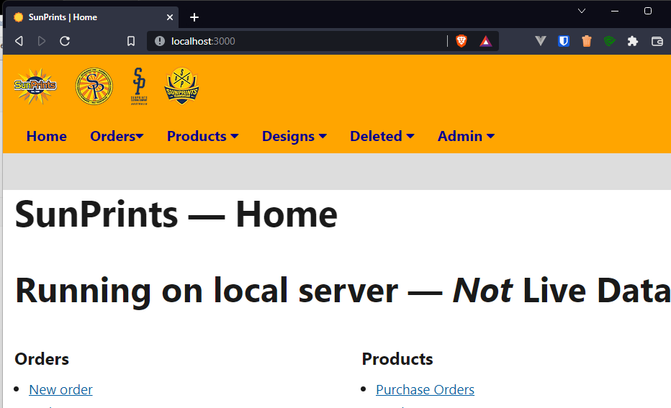

Running locally like this is only intended for looking up details such as customer details orders. You can save changes, but they will not be synchronised with the main database.

## C: Updating the database

You can refresh your local database by copying the sunprints.db file from s:\website to your folder c:\sunprintsweb

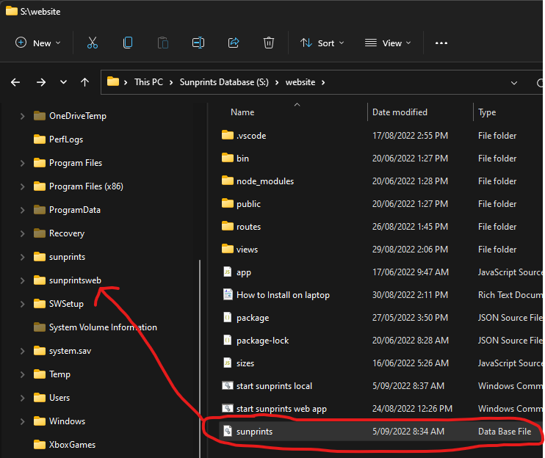

## D. Updating the application

From time to time to updates are made to the web application and you might want to copy these updates to your own local install.

1. Repeat Part A, step 4. Copy all the files from s:\website to c:\sunprintsweb.

2. Close the command window you opened in Part B. Do Part B again, double clicking the command at “c:\sunprintsweb\start sunprints local”

3. Refresh your browser window.